Stock Stalker

(Stock Market Forecast)

# Table of contents

1. Introduction
2. Project Vision
3. High Level Use Cases
4. System Architecture / Flow diagram
   1. Use case Diagram
5. Project Plan
   1. Iteration I work
      1. Expanded use cases
      2. Domain Model
      3. SSD
      4. Operation contracts
      5. Sequence Diagrams
      6. Class Diagram
      7. Deployment Diagram
      8. Package Diagram

# Introduction

Algorithmic trading is a method of executing large order (too large to execute all at once) using automated per-programmed trading instructions accounting for a variety of variables such as time, price and volume to send smaller slices (child orders) out to the market over time. They were developed so that traders do not need to constantly watch the stock and repeatedly send slices out manually. Popular algorithms include Percent of Volume, Pegged, VWAP, TWAP, Implementation Shortfall, and Target Close.

Algorithm trading is widely used by investment banks, pension funds, mutual funds, hedge funds and other buy-side (investor-driven) institutional traders. It is a way to minimize the cost, market impact and risk in execution of an order.

1. **Project Vision**

We envision building a real time stock price prediction system, which will be able to predict the next hour stock price of a particular company’s stock. We seek to provide the traders or brokers with a unique system to help them to take a trading decision in a more systematic and efficient way.

1. **Previous Research**

Prediction will continue to be an interesting area of research making researchers in the domain field always desiring to improve existing predictive models. The reason is that institutions and individuals are empowered to make investment decisions and ability to plan and develop effective strategy about their daily and future endeavours.

Stock price prediction is regarded as one of most difficult task to accomplish in financial forecasting due to complex nature of stock market. The desire of many investors is to lay hold of any forecasting method that could guarantee easy profiting and minimize investment risk from the stock market. This remains a motivating factor for researchers to evolve and develop new predictive models. In the past years several models and techniques had been developed to stock price prediction. Among them are artificial neural networks (ANNs) model which are very popular due to its ability to learn patterns from data and infer solution from unknown data. Few related works that engaged ANNs model to stock price prediction are. In recent time, hybrid approaches has also been engaged to improve stock price predictive models by exploiting the unique strength of each of them. ANNs is from artificial intelligence perspectives.

1. **High Level Use Cases**

**High-Level Use Case 1**

|  |  |
| --- | --- |
| Name | Show Live Streaming |
| Actor | User |
| Description | The system will allow the user to choose between multiple companies to show the stock prices of current hour and the predicted values of the next hour for the company selected. |

**High-Level Use Case 2**

|  |  |
| --- | --- |
| Name | Show History records |
| Actor | User |
| Description | The system will allow the user to choose between multiple companies to show their history records from the past along with our predictions and tell the user exactly how closes our prediction was. |

**High-Level Use Case 3**

|  |  |
| --- | --- |
| Name | Show Finance News |
| Actor | User |
| Description | The system will allow the user to choose between multiple companies to show the trending finance news of that company selected. |

**High-Level Use Case 4**

|  |  |
| --- | --- |
| Name | Show Twitter Feeds |
| Actor | User |
| Description | The system will allow the user to choose between multiple companies to show the tweets of their official page along with tweets from other people for the company. |

1. **Flow Diagram**

**4.1 Use Case Diagram**

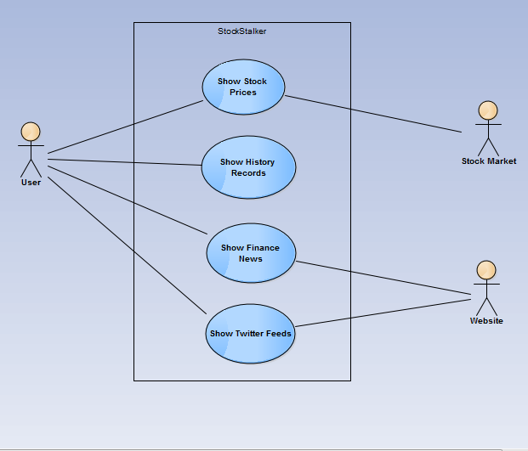

1. **Project Plan**

**5.1 Iteration 1**

**5.1.1 Expanded Use Cases**

**Expanded Use Case 1:**

**Use Case Name**: Show Stock Prices

**Scope**: Stock Stalker – Stock Market Forecast

**Level**: User goal

**Primary Actor**: User

**Stakeholders & Interests**:

* Users: User aim to see the stock prices for current hour of a particular company

**Pre-conditions**:

* User should have chosen at least one company to perform further operations.

**Post-conditions**:

* System should successfully display the candlestick chart for the chosen company’s stock.

**Main Success Scenario**:

|  |  |  |
| --- | --- | --- |
| **Number** | **Actor Actions** | **System Responsibility** |
| 1 |  | System displays the drop down menu for available companies. |
| 2 | User chooses the company from available list. |  |
| 3 | User chooses to show data from drop down menu. |  |
|  |  | System shows the past hourly data and predicted next hours data of the company’s stock. |

**Alternatives and Extensions**:

If an error occurs, the user is unable to see the predicted result and current data. System will show the failure error accordingly.

**Expanded Use Case 2:**

**Use Case Name**: Show History records

**Scope**: Stock Stalker – Stock Market Forecast

**Level**: User goal

**Primary Actor**: User

**Stakeholders & Interests**:

* Users: User aim to see the historical stock prices of a particular company and how much the system was in predicting those values.

**Pre-conditions**:

* User should have chosen at least one company to perform further operations.

**Post-conditions**:

* System should successfully display the candlestick chart for the chosen company’s stock along with system predicted values.

**Main Success Scenario**:

|  |  |  |
| --- | --- | --- |
| **Number** | **Actor Actions** | **System Responsibility** |
| 1 |  | System display the drop down menu for available companies. |
| 2 | User chooses the company from available list. |  |
| 3 | User chooses to show historical data from drop down menu. |  |
|  |  | System shows the historical data of the company’s stock. |
|  |  | System shows the predicted historical stock market data. |

**Alternatives and Extensions**:

If an error occurs, the user is unable to see the historical records and closeness of the system with actual stock prices. System will show the failure error accordingly.

**Expanded Use Case 3:**

**Use Case Name**: Show Finance News

**Scope**: Stock Stalker – Stock Market Forecast

**Level**: User goal

**Primary Actor**: User

**Stakeholders & Interests**:

* Users: User aim to see the finance news of a particular company.

**Pre-conditions**:

* User should have chosen at least one company to perform further operations.

**Post-conditions**:

* System should successfully display the finance news with respect to time for the chosen company.

**Main Success Scenario**:

|  |  |  |
| --- | --- | --- |
| **Number** | **Actor Actions** | **System Responsibility** |
| 1 |  | System display the drop down menu for available companies. |
| 2 | User chooses the company from available list. |  |
| 3 | User chooses to show finance news from drop down menu. |  |
|  |  | System shows the finance news of the company. |

**Alternatives and Extensions**:

If an error occurs, the user is unable to see the finance news. System will show the failure error accordingly.

**Expanded Use Case 4:**

**Use Case Name**: Show Twitter Feeds

**Scope**: Stock Stalker – Stock Market Forecast

**Level**: User goal

**Primary Actor**: User

**Stakeholders & Interests**:

* Users: User aim to see the twitter feeds of a particular company.

**Pre-conditions**:

* User should have chosen at least one company to perform further operations.

**Post-conditions**:

* System should successfully display the twitter feeds with rest to time for the chosen company. These tweets will consist of the official company page (which will be bold) along with people tweeting about the company selected.

**Main Success Scenario**:

|  |  |  |
| --- | --- | --- |
| **Number** | **Actor Actions** | **System Responsibility** |
| 1 |  | System display the drop down menu for available companies. |
| 2 | User chooses the company from available list. |  |
| 3 | User chooses to show twitter feeds from drop down menu. |  |
|  |  | System shows the finance news of the company. |

**Alternatives and Extensions**:

If an error occurs, the user is unable to see the twitter tweets. System will show the failure error accordingly.

**5.1.2 Domain Model**

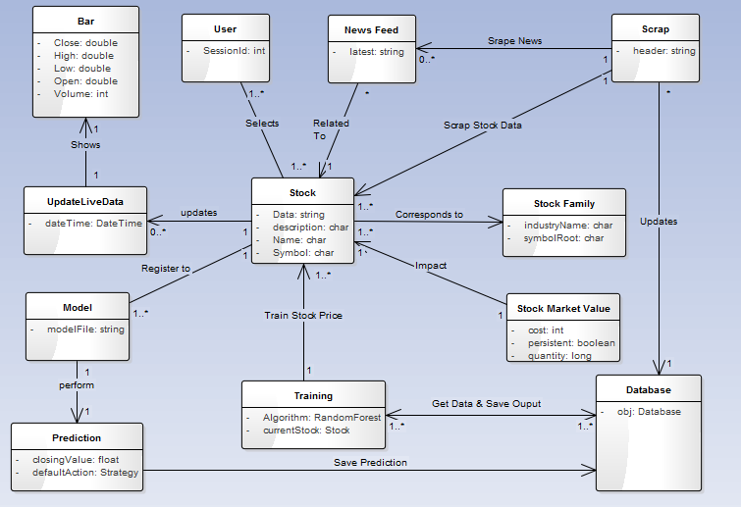

**5.1.3 System Sequence Diagrams**

**1 – showLiveData()**

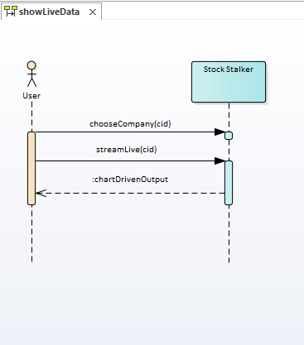

**2 – showPredictedStatistics()**

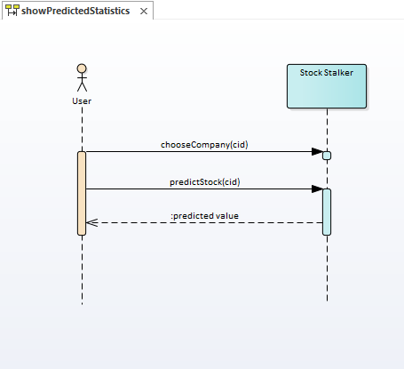

**5.1.4 Operation Contracts**

**1 - ShowStockPrices(cid)**

|  |  |
| --- | --- |
| **Operation Name** | ShowStockPrices(cid) |
| **Responsibility** | It creates an object from where you can view live streaming stock prices with future hourly predictions on colourful charts. |
| **Type** | System |
| **Cross-Reference** | Use Case: Show Stock Prices |
| **Exceptions** | If stock market is off or prices are not being updated, indicate warning. |
| **Pre-conditions** | User/visitor must have selected at least one stock/Company. |
| **Post-Conditions** |  |

**2 - ShowHistoryRecords(cid)**

|  |  |
| --- | --- |
| **Operation Name** | ShowHistoryRecords(cid) |
| **Responsibility** | It gets all the previous data from the database along with predicted prices by the system for a particular stock and displays to the user. |
| **Type** | System |
| **Cross-Reference** | Use Case: Show History Records |
| **Exceptions** | - |
| **Pre-conditions** | An instance of stock “st” must be created.  An instance of Database “db” must be created. |
| **Post-Conditions** |  |

**3 - ShowFinanceNews(cid)**

|  |  |
| --- | --- |
| **Operation Name** |  |
| **Responsibility** | It gets all the previous/current financial news from the database for a particular stock and displays to the user. |
| **Type** | System |
| **Cross-Reference** | Use Case: Show Finance News |
| **Exceptions** | - |
| **Pre-conditions** | An instance of stock “st” must be created.  An instance of Database “db” must be created. |
| **Post-Conditions** |  |

**4 - ShowTwitterFeeds(cid)**

|  |  |
| --- | --- |
| **Operation Name** | ShowTwitterFeeds(cid) |
| **Responsibility** | It gets all the previous/current twitter tweets from the database for a particular stock and displays to the user. |
| **Type** | System |
| **Cross-Reference** | Use Case: Show Twitter Feeds |
| **Exceptions** | - |
| **Pre-conditions** | An instance of stock “st” must be created.  An instance of Database “db” must be created. |
| **Post-Conditions** |  |

**5.1.5 Sequence Diagrams**

**1 – streamLive**

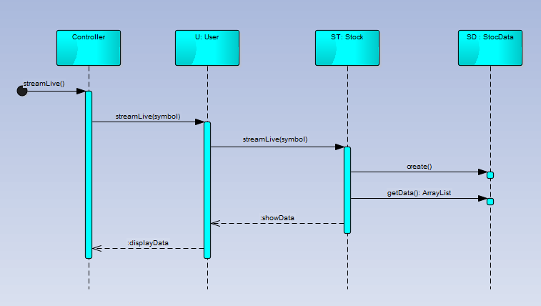

**2 – predictStock**

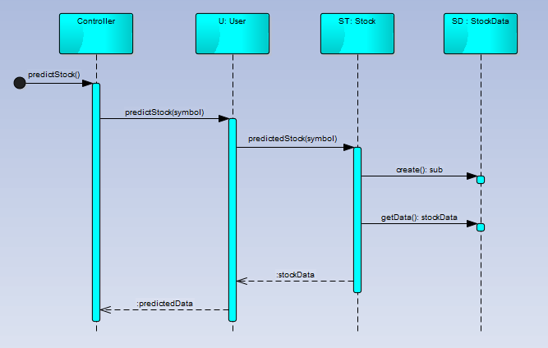

**5.1.6 Class Diagram**

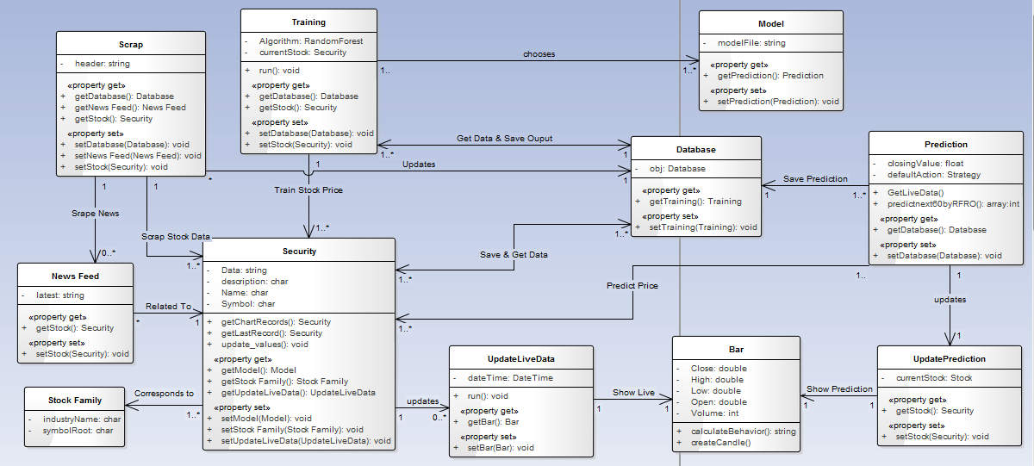

**5.1.7 Deployment Diagram**

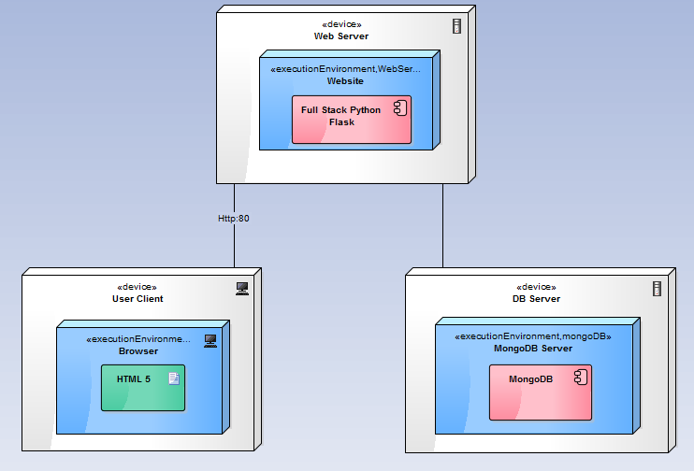

**5.1.8 Package Diagram**

